COORDINATORS

The state educational establishment the National Institute for Higher Education (NIHE) is a recognized republican center for refresher training and retraining, a leader in implementation of innovations in the establishments of higher education of Belarus.
In the course of realization of its educational programmes the Institute widely uses the personnel and lifeware of the education and research of the Republic of Belarus, close partnership relations with the institutes of the CIS, the U.N.O., UNESCO, the Council of Europe, foreign universities, research and information centers.

The State Belarusian University (the BSU) is a leading university of Belarus. The BSU is a member of Eurasian and European associations of universities, it has made 324 international agreements on cooperation with educational and research establishments of 50 foreign countries. On the basis of the BSU there work the Information Center of the European Union, the Republican Institute of Sinology named after Confucius, the Center for International Research. Every year the university implements over 40 international projects within such programmes as TEMPUS, INTAS, Transboundary Cooperation of the EU, the 7th Framework Programme of the EU, MNTC.

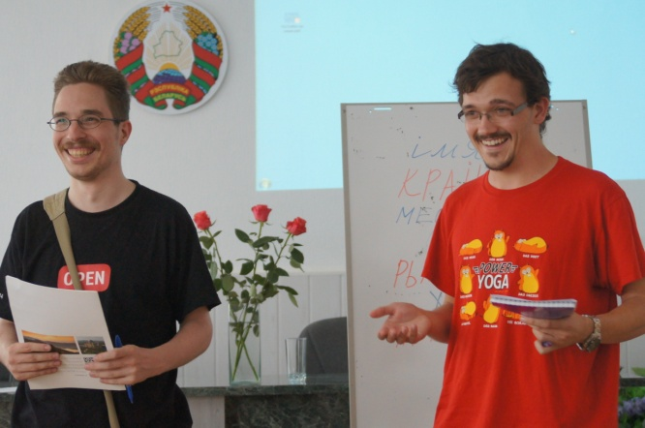

THE PROGRAMME

Studying at the International Summer School of Belarusian Studies has an interdisciplinary character and includes four components of Belarusian Studies, they are the language, the literature, the history and the culture. The curriculum includes academic classes (lectures on topical issues of the Belarusian linguistics and philology, the history of Belarus, the cultorology and a practical course of the Belarusian language) as well as interactive events, round-table discussions, master-classes and educational excursions.

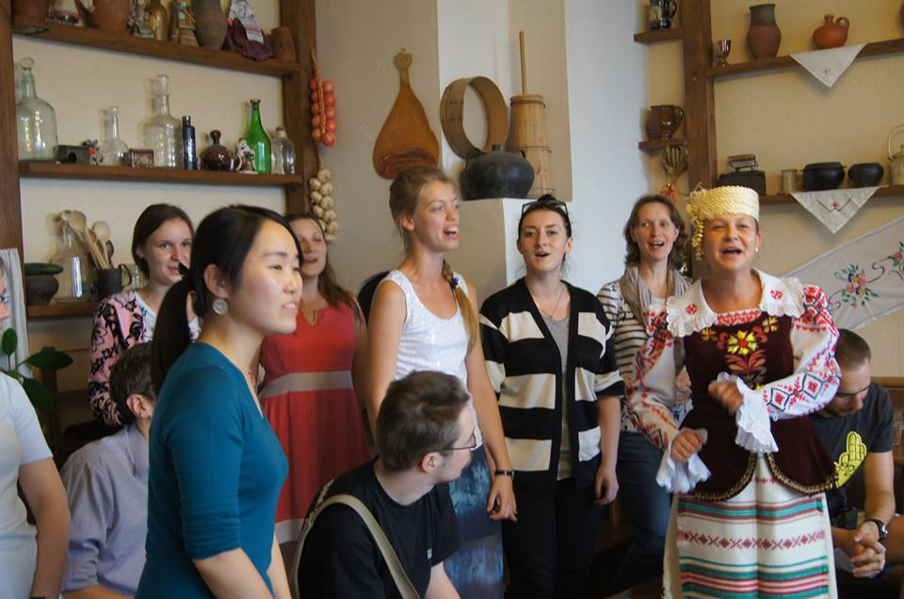

A practical course of the Belarusian language (48 hours) is designed to assist the participants of the Summer School to adapt themselves to the new communication and discourse conditions. The curriculum is meant for both the elementary students and those who continue studying of the Belarusian language. One of the main objectives of the School is to present efficient strategies of learning that would allow the participants to continue studying the Belarusian language autonomously upon finishing the Summer School.

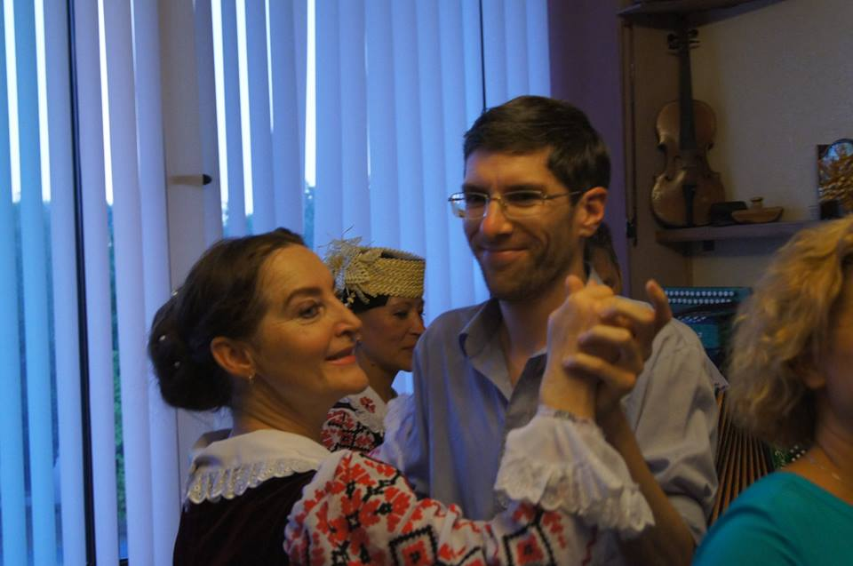

The cultural programme of the Summer School is aimed at enhancing communication and cultural competences of the participants and includes visiting museums, exhibitions, libraries, acquaintance with monuments of the architecture of Belarus, meetings with representatives of public organizations, people of science, culture, arts, with students of Belarusian educational establishments.

Let’s start speaking Belarusian
(the Belarusian language for Elementary level students)
(Level А)

You will be able to:
- participate in communication in Belarusian, get acquainted using the norms of Belarusian speech etiquette;
- ask questions, provide information on facts and objects, express needs, requests, invitations, agreement or disagreement;
- use the Belarusian language at the university, libraries, shops, bank and post offices, cafes, public transport.

Let’s speak Belarusian
(the Belarusian language for Intermediate level students)
(Level В)

You will be able to:
- participate actively in conversations on topics including: about oneself, one’s family, friends, studies, work, country, native town, national holidays, customs and traditions;
- study at higher educational establishments of the Republic of Belarus in Belarusian, discuss the problems of arts, history and culture.

Let’s master Belarusian
(the Belarusian language for Advanced level students)
(Level С)

You will be able to:
- discuss topical issues including occupational, social, cultural, and general humanistic topics (the man and the society, politics, economics, philosophy, psychology, the man and the science, the man and the art, the man and the nature, spiritual development of a person);
- improve one’s professional skills (the urgent trends in the development of the Belarusian language at the current stage, active processes in the modern Belarusian language, modern conceptions for the description of the Belarusian language as a foreign one, innovative lingvodidactic technologies in teaching the Belarusian language).

CONTACTS:
SEE the National Institute for Higher Education
Maskouskaya str., 15, room 321
220007, Minsk, the Republic of Belarus
Tel./Fax (017)-396-30-75,
Tel. (017)-256-08-40
e-mail: kmpnihe@mail.ru
Site: http://nihe.bsu.by/
Facebook: www.facebook.com/groups/738751556202643/

Director: Prof. Syameshka Lidia

Coordinator: Makovchik Svetlana
THE NATIONAL INSTITUTE FOR HIGHER EDUCATION

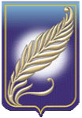
THE BELARUSIAN STATE UNIVERSITY

THE INTERNATIONAL SUMMER SCHOOL OF BELARUSIAN STUDIES

The 30th of June –
the 15th of July 2016

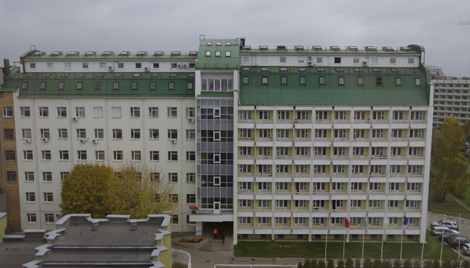

Minsk 2016
The Republic of Belarus

